Stop One. Jester East dormitory. Monday 10/19/2020. Now that I think about it, a year after we (my education) were recording at Sonic Ranch. I have a lot of very vivid memories of Jester East, definitely the poor red-headed stepchild of Jester West. HAS ITS OWN ZIP CODE! Etc. Our room looked right out over the athlete’s cafeteria, which smelled like it had much better food than ours, and there were many rumors of the fantastic all you can eat steak and shrimp dinners they had in there…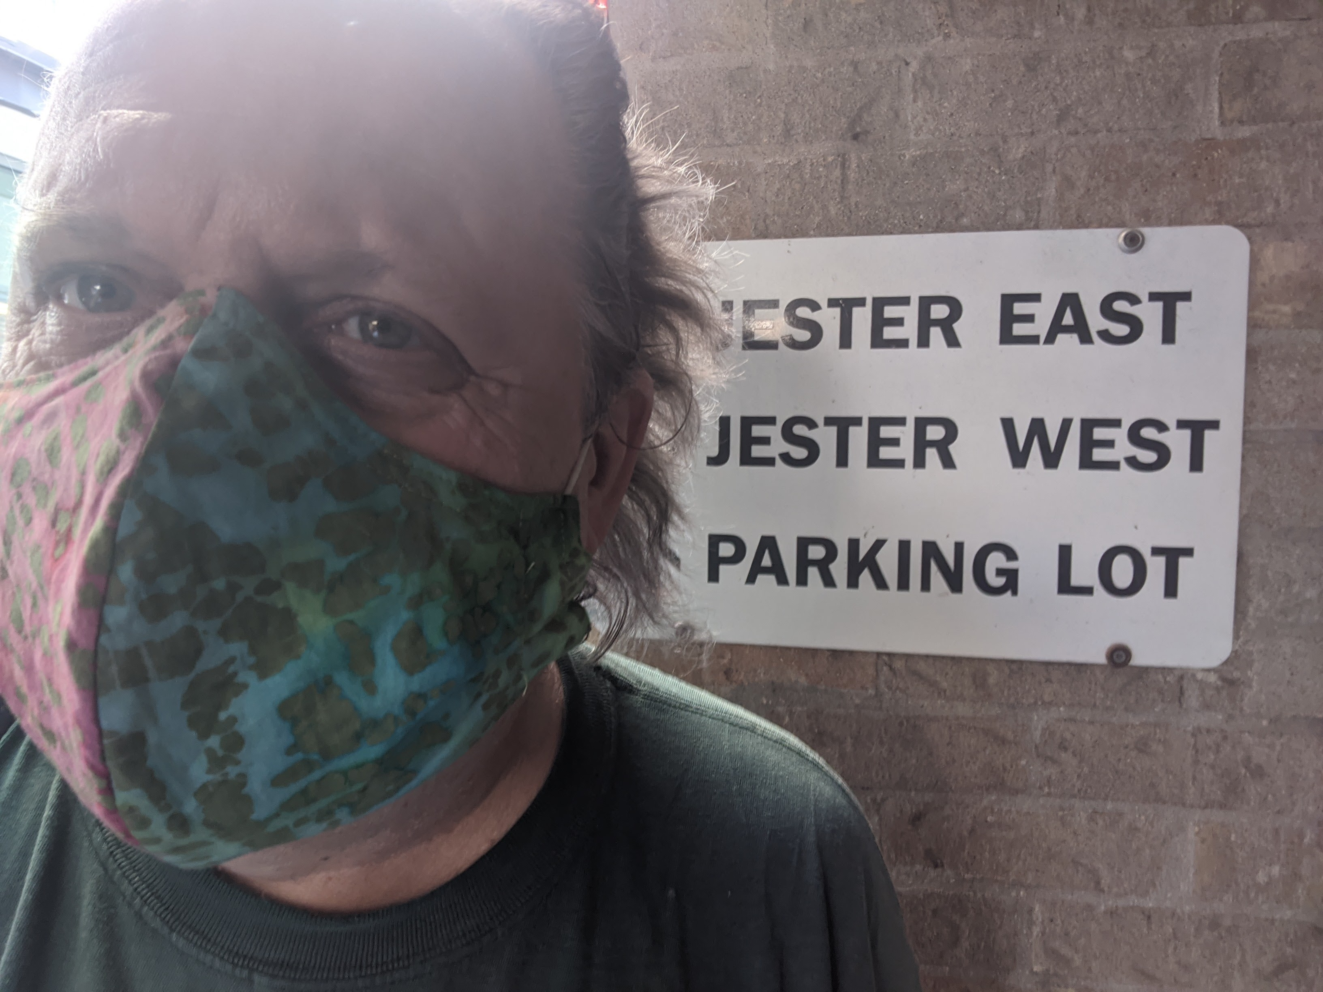
Of course they wouldn’t let me in there anywhere near rm. 316, the abode of myself and Jim Sweeney for the 1980-81 school year. Unsurprisingly. So I had to settle for this pic right outside the entrance to East.
Bike did pretty well. Out of shape me had to walk up a few hills on the way back.

